Activities for the Multicultural Badge

Art – The Koru

The koru is the Maori name given to the new unfurling fern frond and symbolizes new life, growth, strength and peace. It is an integral symbol in Maori carving and tattoos.

What You Need:
- Large cartridge paper
- Chalk pastels
- Oil Pastels
- Black dye (ink or tempera paint will also work)

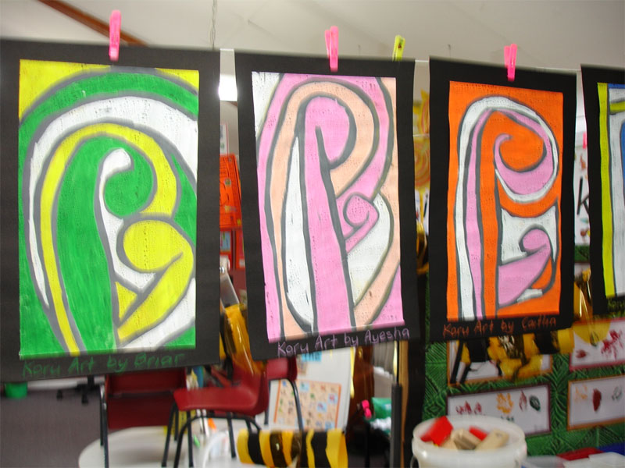
What You Do:
- Introduce the girls to Maori Koru designs through Maori Legends.
- Look at ferns (or pictures of ferns) and discuss their shape as they unfold.
- Spend a few days on practicing forming a koru shape on newsprint with crayons. Get girls to draw one large koru then little korus attached to the large one. Let them experiment and do as many as they wish. Every time they draw a line, they should draw a double line instead of a single one (see examples above).
- When ready, girls draw a large koru on the cartridge paper, using chalk. Then they draw some little ones attached to the large one. Every time they draw a line, they should draw a double line instead of a single one (see examples above).
- Let the girls choose two oil pastel colours. These will be used to fill in the designs.
- The first colour is for inside the korus. The second colour is for all the gaps. (Tip: Use a small piece of newsprint to rest their hand/arm on so there is no smudging). The areas within the double lines should remain clear of pastels. These areas will be filled in with black dye later on.
- Once all the oil pastels areas are coloured in, wash the black dye over the entire piece. The double lines will appear black.

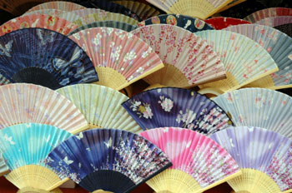
Japanese Fan:

What You Need:
- 30cm x 46cm white paper
- watercolours
- paintbrushes
- fans or pictures of fans
- popsicle sticks
- tape

What You Do:
- Discuss uses of fans such as functional use and artistic use.
- Fold paper in half horizontally (like a book).
- On the folded side draw half of a fan shape (like a rainbow) and cut. The piece will resemble a rainbow shape.
- Lightly draw a piece from nature e.g. leaning trees with branches and leaves.
- Using watercolour, make bold brush strokes and use a quick brush stroke to fill in leaves. Use several colours of paint with the seasons. Let dry.
- Fold the paper back and forth, creasing each time. Gather the paper together to form the fan and staple or glue.
- Tape two popsicle sticks together to form a handle.
- Display it and enjoy.

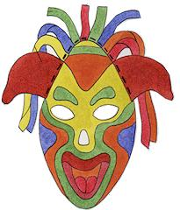
Colourful Paper Masks:
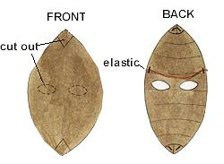
Masks are a way to make faces that lift and transport us to new and wild places. From a bird to a beast to a sad happy clown, masks make you laugh, make you jump, make you frown. Using paper and scissors and objects you find, you can make masks of all colours and kinds.
Masks have different meaning in different cultures – you may like to check some of these out on the internet.

What You Need:
- Heavy poster paper about 50cm x 70cm per student (can be smaller depending on what's available.)
- Pencils
- Scissors
- A paper stapler
- Crayons
- Paint
- Paintbrushes and containers for water
- Magic markers, feathers and other found objects
- Glue
- String or elastic

What You Do:
When making masks, take the opportunity to discuss false faces and masks from around the world. You could have a discussion about how everyone wears different "masks" from day to day ... when we are sad, happy or scared.
- Draw an oval shape on the large piece of paper. The larger the better ... masks can cover more than just the face. Cut the oval shape out of the paper.
- At both the top and bottom of the oval, make a 2.5cm cut. (You will later take these cuts, fold the paper across itself and staple so the mask has some dimension).
- Draw and cut out where the eye holes and mouth and nose holes (if any) are going to be.
- Decorate the mask by using bright crayon colours or bright paint colours.
- Even more details can be added with magic markers and crayons.
- Now, where you made your cuts, fold the paper and staple in place. This will give your mask more dimensions.
- Glue found object decorations on the mask. Anything from feathers and string to beads and tissue paper.
- Staple string onto the mask so it can be tied around the head.

Make a tangram for Chinese New Year.
Tangram is an ancient Chinese puzzle. This activity is sometimes called "seven pieces of cleverness." The object of the puzzle is to rearrange the pieces of a square (the puzzle pieces) to form figures (like a picture of a cat) using the tangram pieces.
Supplies:
- Paper (cardstock or other thick paper works well)
- Scissors
- Ruler and Pencil or a Printer
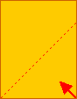 | Start by making a square piece of paper. To start making the square, fold one corner of a piece of paper over to the adjacent side. Or, go to a tangram template to print and skip the next 3 steps.

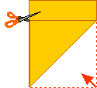 | To finish making the square, cut off the small rectangle, forming a square.

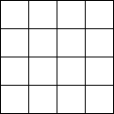 | Fold the square piece of paper in half, then in half again (making a square that is divided into quarters). Repeat this step (resulting in a square divided into sixteenths).  Unfold the paper.

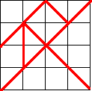 | Draw lines along the red lines marked at the left. Cut along these lines.

 | You will now have seven pieces: a small square, two small isosceles triangles, a medium-sized isosceles triangle, two large isosceles triangles, and a parallelogram.  {An isosceles triangle has two equal angles and two equal sides. A parallelogram is a four-sided figure with each side parallel to the opposite side.}

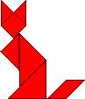  cats | You can arrange these seven pieces into an incredible number of shapes, making animals, people, everyday objects, etc. See how many you can make - invent new ones! |   dancers
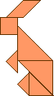
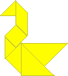
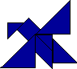
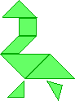

Swan Bird Candle Duck Rabbit

Multicultural Collage:

A collage is a simple way to represent many different cultures in one work of art. Collect a variety of magazines that will allow the girls to find pictures of people and artefacts from different cultures. The pictures are cut out and glued to the collage. The girls can also add their own drawings to the collages.

Cook Islands:

Making a tivaevae or place mat.

There are two principal techniques piecework and appliqué. The first is patchwork made from tiny pieces of coloured cloth sewn together on a backing. Tivaevae tataura are made in several colours on a contrasting background. The pattern is created from separate pieces of fabric which may be richly embroidered either beforehand or onto the background fabric. Appliqué usually involve two colours, the first for the pattern, the second for the background. Tivaevae manu are made in only two colours, the pattern is folded four or eight times, cut and stitched onto a contrasting base cloth.
Exhibitions of tivaevae are very popular in both the Cook Islands and the cities of New Zealand. As well as being shown at displays, tivaevae are given on important family and social occasions such as weddings and the traditional hair cutting ceremony for boys when they come of age. They are used also at funerals and sometimes the body is wrapped in one.

Here are some designs that have been used on Tivaevae. The girls could create a simpler design and instead of making a large tivaevae they could make one the size of a place mat.
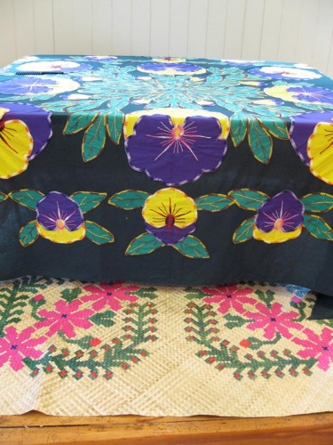
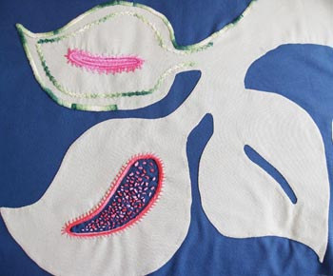

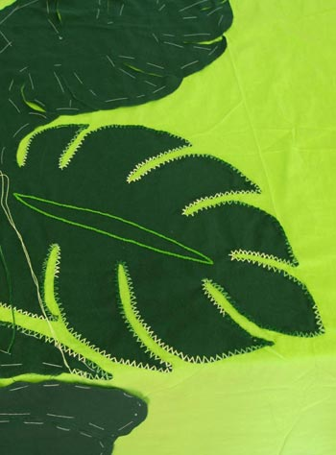

Kiwiana Activities:
- Make a pavalova, decorate then the girls can eat it and share some L & P
- Bake something from the Edmonds Cook Book
- Visit a second hand shop to see what Kiwiana the girls can find OR take them to some garage sales to see if there is any Kiwiana there?
- Make something out of Paua shell

